

# Ranjani.S

# 241801224

# AIDS-D

Question 1: Boxes through a Tunnel

Problem Statement:

You are transporting some boxes through a tunnel, where each box is a parallelepiped, and is characterized by its length, width and height.

The height of the tunnel is 41 feet and the width can be assumed to be infinite. A box can be carried through the tunnel only if its height is strictly less than the tunnel's height. Find the volume of each box that can be successfully transported to the other end of the tunnel.

Note: Boxes cannot be rotated. Input Format

The first line contains a single integer n, denoting the number of boxes.

n lines follow with three integers on each separated by single spaces - lengthi, widthi and heighti which are length, width and height in feet of the i-th box.

Constraints 1 ≤ n ≤ 100

1 ≤ lengthi, widthi, heighti ≤ 100 Output Format

For every box from the input which has a height lesser than 41 feet, print its volume in a separate line.



Sample Input 4

5 5 5

1 2 40

10 5 41

7 2 42

Sample Output 125

80

Explanation

The first box is really low, only 5 feet tall, so it can pass through the tunnel and its volume is 5 x 5 x 5 = 125.

The second box is sufficiently low, its volume is 1 x 2 x 4= = 80.

The third box is exactly 41 feet tall, so it cannot pass. The same can be said about the fourth box.

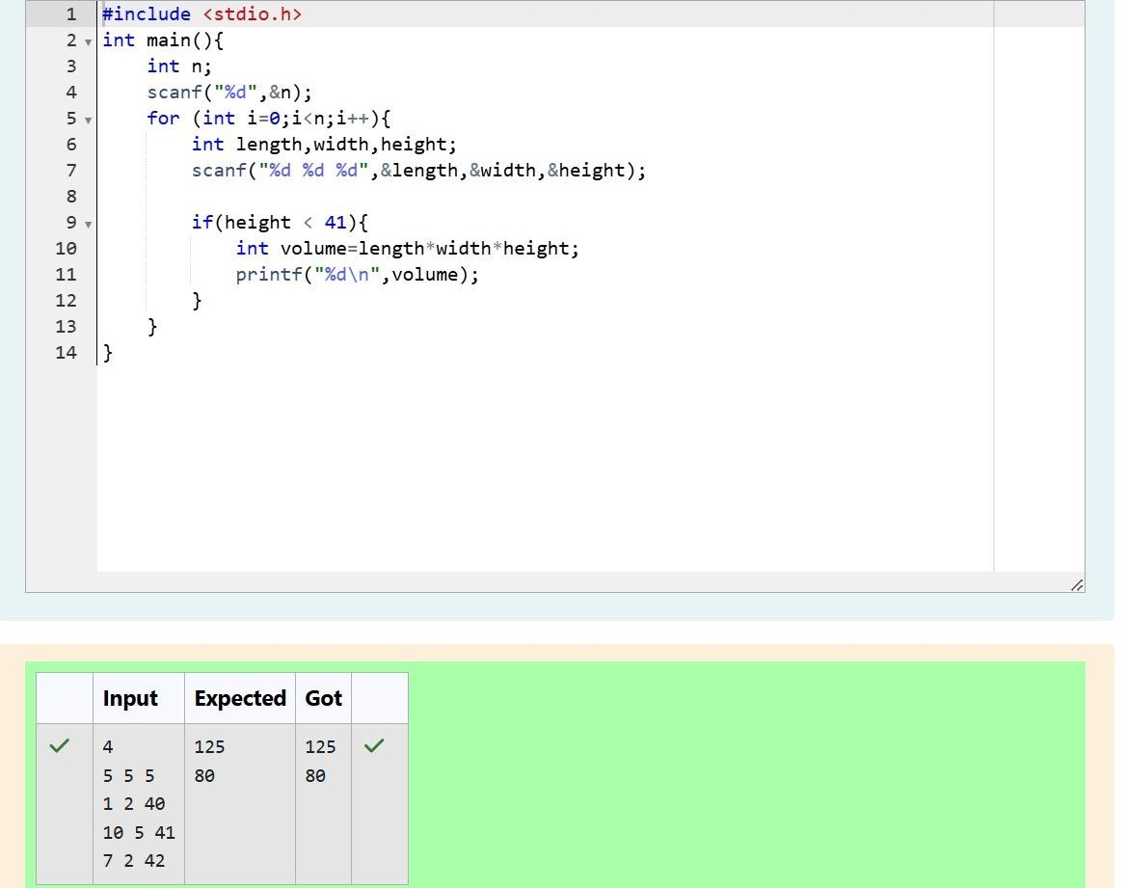

# Question 2: Small Triangles, Large Triangles

You are given n triangles, specifically, their sides ai, bi and ci. Print them in the same style but sorted by their areas from the smallest one to the largest one. It is guaranteed that all the areas are different.

The best way to calculate a volume of the triangle with sides a, b and c is Heron's formula: S = p * (p – a) * (p - b) * (p – c) where p = (a + b + c) / 2.

Input Format

First line of each test file contains single integer n. n lines follow with ai, bi and ci on each separated by single spaces.

Constraints 1 ≤ n ≤ 100

1 ≤ ai, bi, ci ≤ 70

ai + bi > ci, ai + ci > bi and bi + ci > ai Output Format

Print exactly n lines. On each line print 3 integers separated by single spaces, which are ai, bi and ci of the corresponding triangle.

Sample Input 3

7 24 25

5 12 13

3 4 5

Sample Output 3 4 5

5 12 13

7 24 25

Explanation

The square of the first triangle is 84. The square of the second triangle is 30. The square of the third triangle is 6. So, the sorted order is the reverse one.

